GANPAT UNIVERSITY

U.V. PATEL COLLEGE OF ENGINEERING

B.Tech 3rd Semester
(Computer Engineering/Information Technology)

Lab Manual

Subject Code: 2CEIT301
Subject Name: Digital Electronics

EXPERIMENT NO.: - 1

AIM: To study the basic logic gates which are used in digital circuits

THEORY:

Any Gate is a logic circuit with one output and one or more inputs. The output signal of any gate occurs only for certain combination of input signals. Different types of gates are used in the digital circuit like AND gate, OR gate, NOR gate, NAND gate, NOT gate are the basic logic gates. Some gates are the combination of above basic gates. Such gates can be prepared by using discrete components like diodes, transistors, and resisters but nowadays, different ICs are used to have different gates. A power supply of +5 V is used to give input. This supply is also used to drive ICs. When power supply to the input is 'ON' we can say that logic level is at '1' and when power supply to the input is 'OFF' the logic level is said to be at '0' level.

AND GATE:
AND gate is a gate which gives output (output at '1' level) only when all inputs are present (i.e. all inputs are at '1' level). Here IC 7408 is used which has 2-inputs AND gate which are four in numbers. Here only one gate is used. The truth table of AND gate is given in the table.

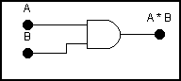
A | B | OUTPUT
0 | 0 | 0
0 | 1 | 0
1 | 0 | 0
1 | 1 | 1

Practical Figure:

OR GATE:
OR gate is a gate which gives output (output at '1' level) when any ONE of the input is present (any ONE out of all input must be at '1' level). Here IC 7432 is used which has two input OR gates which are four in numbers. The truth table of OR gate is given in the table.
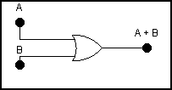
A | B | OUTPUT
0 | 0 | 0
0 | 1 | 1
1 | 0 | 1
1 | 1 | 1

Practical Figure:

NOT GATE:
This is also known as INVERTER gate. This gate has one input and one output. All it does is invert the input signal i.e. if the input is at high level, the output will be at low level and vice versa. ICs 7404 or 7406 can be used to get NOT gates, which are six in numbers. The truth table of NOT gate is given in the table.

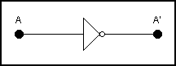
A | OUTPUT
0 | 1
1 | 0

Practical Figure:

EQUIPMENTS REQUIRED:

Trainer kit or Bread Board, Power Supply and LEDs.

COMPONENTS REQUIRED:

-ICs 7408, 7432, 7404.
-Hook up wires.

PROCEDURE:

- Pull all switches at ‘0’ position.
- Switch ON the power supply.
- Test the truth table of different gates by changing the position of inputs (i.e. ‘1’ level means switch is ON & ‘0’ level means switch is OFF) and check the level of output (if LED glows it is at level ‘1’ and if LED doesn’t glow output is at level ‘0’).

OBSERVATIONS:

CONCLUSION:

EXPERIMENT NO.: - 2

AIM: To study NAND and NOR gates as Universal Gates.

THEORY:
Any Gate is a logic circuit with one output and one or more inputs. The output signal of any gate occurs only for certain combination of input signals. Different types of gates are used in the digital circuit. AND neither gate, OR gate, NOR gate, NAND gate, NOT gate are the basic logic gates. Some gates are the combination of above basic gates. Such gates can be prepared by using discrete components like diodes, transistors, and resisters but nowadays, different ICs are used to have different gates. A power supply of +5 V is used to give input. This supply is also used to drive ICs. When power supply to the input is 'ON' we can say that logic level is at '1' and when power supply to the input is 'OFF' the logic level is said to be at '0' level.

NAND GATE:
It is a sequence of series combination of AND gate and NOT gate, known as NAND gate. The output of NAND gate is at ‘0’ level only when all the inputs are ‘1’ level. In rest of all the conditions of inputs the output will be at level ‘1’. IC 7400 can be used to get NAND gate. This IC has two input NAND gates, which are four in numbers. The truth table of NAND gate is given in the table.

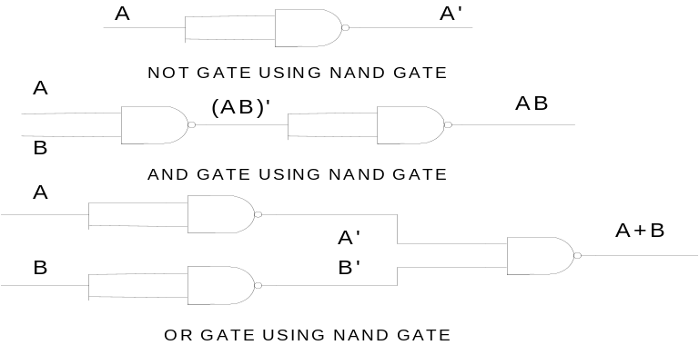
A | B | OUTPUT
0 | 0 | 1
0 | 1 | 1
1 | 0 | 1
1 | 1 | 0

Practical Figure:

NOR GATE:
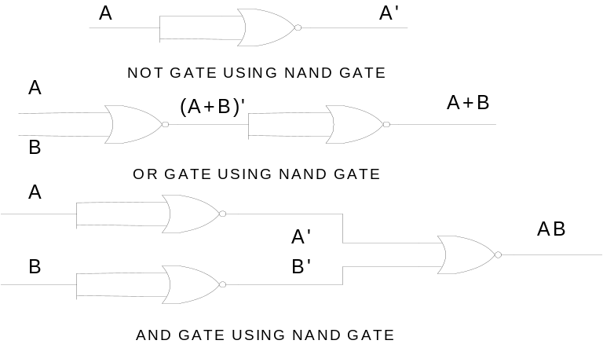It is a sequence of series combination of OR gate and NOT gate. The output of NOR gate is at level ‘1’ when all the inputs are at ‘0’ level. In rest of all the conditions of inputs the output is at ‘0’ level. IC 7402 can be used to get NOR gate. It neither has two input NOR gates, which are four in numbers. The truth table of NOR gate is given in table.
A | B | OUTPUT
0 | 0 | 1
0 | 1 | 0
1 | 0 | 0
1 | 1 | 0

Practical Figure:

EQUIPMENTS REQUIRED:

Trainer kit or Bread Board, Power Supply and LED’s.

COMPONENTS REQUIRED:
-ICs 7400, 7402
-Hook up wires

PROCEDURE:

1. Pull all switches at ‘0’ position.
- Switch ON the power supply.
- Test the truth table of different gates by changing the position of inputs (i.e. ‘1’ level means switch is ON & ‘0’ level means switch is OFF) and check the level of output (if LED glows it is at level ‘1’ and if LED doesn’t glow output is at level ‘0’).

OBSERVATIONS:

CONCLUSION:

EXPERIMENT NO.: - 3(A)

AIM: To study the arithmetic function of addition by building Half Adder circuit using logic gates.

THEORY:
This experiment gives how computer does the function of addition. The addition of two numbers in binary which does no have “carry” is done by half adder circuit and the addition of two numbers in binary which have “carry” is done by full adder circuit.

The half adder adds two-binary digit at a time. Fig. given below shows how to make half adder by using two logic gates namely AND gate and EX-OR gate. The truth table of EX-OR gate is as below:

EX-OR Gate:

A | B | OUTPUT
0 | 0 | 0
0 | 1 | 1
1 | 0 | 1
1 | 1 | 0
As shown in the following figure the output of AND gate is used as “carry” bit and the output of EX-OR gate is used as “sum” bit. There will be four distinct cases which are shown in following truth table.
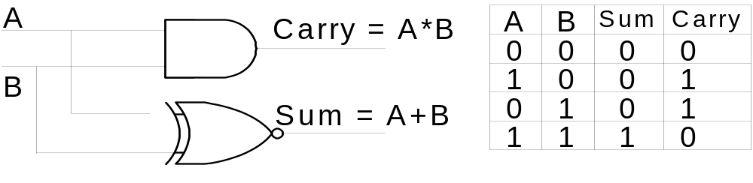

EQUIPMENT REQUIRED:

-Trainer kit

COMPONENTS REQUIRED:

-ICs 7486, 7408.
-Hook up wires.

PROCEDURE:
- Connect 5V DC power supply to input terminals.
- Change the state of A & B (0 & 1) to get four states at output by changing the position of micro switch. Check the truth table of half adder. ( If LED glows it is High state and if it does not glow then it is Low state)

OBSERVATIONS:

CONCLUSION:

EXPERIMENT NO.: - 3(B)

AIM: To study the arithmetic function of addition by building Full Adder circuit using logic gates.

THEORY:

This experiment gives how computer does the function of addition. The addition of two numbers in binary which does no have “carry” is done by half adder circuit and the addition of two numbers in binary which have “carry” is done by full adder circuit. Sometimes in addition of two binary numbers you may have a carry from one column to the next. So in the next column we have to add three digits. This is not possible by half adder circuit. This is carried by a circuit as shown in fig.1 which consists of two half adder circuits and an OR-gate. This is known as full adder circuit.

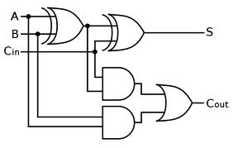

As shown in figure.1 the output of AND gate is used at “carry” bit and the output of EX-OR gate is used as “sum” bit. There will be four distinct cases which are shown in following truth table.

A | B | Cin | CARRY(Cout) | SUM
0 | 0 | 0 | 0 | 0
0 | 0 | 1 | 0 | 1
0 | 1 | 0 | 0 | 1
0 | 1 | 1 | 1 | 0
1 | 0 | 0 | 0 | 1
1 | 0 | 1 | 1 | 0
1 | 1 | 0 | 1 | 0
1 | 1 | 1 | 1 | 1

EQUIPMENT REQUIRED:

-Trainer kit

COMPONENTS REQUIRED:

-ICs 7408, 7432, 7486.
-Hook up wires.

PROCEDURE:
- Connect 5V DC power supply to input terminals.
- Change the state of A & B (0 & 1) to get four states at output by changing the position of micro switch. Check the truth table of half adder. ( If LED glows it is High state and if it does not glow then it is Low state)

OBSERVATIONS:

CONCLUSION:

EXPERIMENT NO.: - 4(A)

AIM: To Design Half-subtractor.

THEORY:

A combination circuit that performs the arithmetic subtraction of two bits is called half subtractor. In figure we assigns two symbols a and b are two input variables and D (difference) and B (borrow) are two output variables. The truth table for half subtractor is shown in figure.
D = a’b + ab’
= a ⊕ b
B = ab’
The half subtractor consists of an X-OR gate and AND gate.

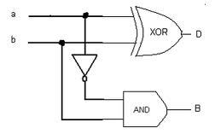
A | B | D | B
0 | 0 | 0 | 0
0 | 1 | 1 | 1
1 | 0 | 1 | 0
1 | 1 | 0 | 0

EQUIPMENTS REQUIRED:

-Trainer kit

COMPONENTS REQUIRED:

- Connecting wires
- IC 7408 (AND gate)
- IC 7486 (X-OR gate)
- IC 7432 (OR gate)

PROCEDURE

- Join the circuit as per circuit diagram.
- Verify the truth-table.

OBSERVATIONS:

CONCLUSION:

EXPERIMENT NO.: - 4(B)

AIM: To design Full-subtractor.

THEORY:

A combination circuit that performs the arithmetic subtraction of three bits is called full subtractor. In figure we assigns three symbols X, Y and Z are three input variables and D (difference) and B(borrow) are two output variables. The truth table for full subtractor is shown in figure.

D = x ⊕ y ⊕ z
B = x’y + x’z + yz

The full subtractor consists of two half-subtractor and one OR gate.

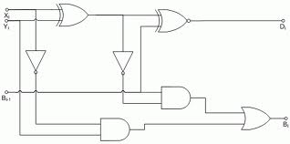

Input |  |  | Output
X | Y | B_{i+1} | Borrow ( B_{i} ) | Diffe ( D )
0 | 0 | 0 | 0 | 0
0 | 0 | 1 | 1 | 1
0 | 1 | 0 | 1 | 1
0 | 1 | 1 | 1 | 0
1 | 0 | 0 | 0 | 1
1 | 0 | 1 | 0 | 0
1 | 1 | 0 | 0 | 0
1 | 1 | 1 | 1 | 1

EQUIPMENTS REQUIRED:

-Trainer kit

COMPONENTS REQUIRED:

- Connecting wires
- IC 7408 (AND gate)
- IC 7486 (X-OR gate)
- IC 7432 (OR gate)

PROCEDURE:

- Join the circuit as per circuit diagram.
- Verify the truth table for full-subtractor.

OBSERVATION:

CONCLUSION:

